Message from Bertha Oliva: “We are living a time of enormous regression as women and as society.”
Open Letter on International Women’s Day from Bertha Oliva, Coordinator of the Committee of the Families of the Detained and Disappeared in Honduras (Cofadeh), who remembers that organizations like hers, that have been demanding truth related to the violations of human rights committed in the 1980s for decades, are comprised mostly of women.
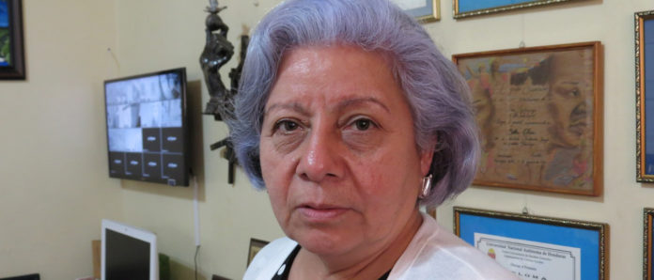Foto: Giorgio Trucchi
Unfortunately, in the current context, to be a woman and to work in the defense of human rights is to confront, every day, institutions that systematically violate the rights of the people, especially the rights of women.
In Honduras, we commemorate this 8th of March in the midst of a dictatorship that is especially focused on silencing the potent voice of the woman who is determined, organized, demands changes and is capable of making the world tremble.
We now have political prisoners because they opposed electoral fraud and protested with the people against corruption and to demand truth and transparency.
The women of this country have been losing the small advances that we had achieved through years of struggle. They want to take away our right to free speech, to protest and the right to life itself.
This March 8th, we must strongly denounce violence against women and the people of Honduras in general; we should condemn a dictatorship without precedent in this country; we should raise our voice against the loss of advances gained by women and human rights defenders.
We are subjected to barbarity. We should collectively and internationally demand the freedom of the 20 political prisoners in the context of the post-electoral crisis.
We should cry out with all of our strength that we will struggle for all of them.
http://defensoresenlinea.com/mensaje-de-bertha-oliva-estamos-viviendo-un-gran-retroceso-como-mujeres-y-como-sociedad/

